Sri Lanka Institute of Information Technology

User Experience Engineering – SE3050

Lab Sheet 06



GROUP ID: **2021S1_REG_WD_05**

|  |  |
| --- | --- |
| **Registration Number** | **Name** |
| IT19153414 | Akeel M.N.M |
| IT19175126 | Zumry A.M |
| IT19167442 | Nusky M.A.M |

**Member 01 – IT19153414 Akeel M.N.M**

**Sketches**

Bill Payment

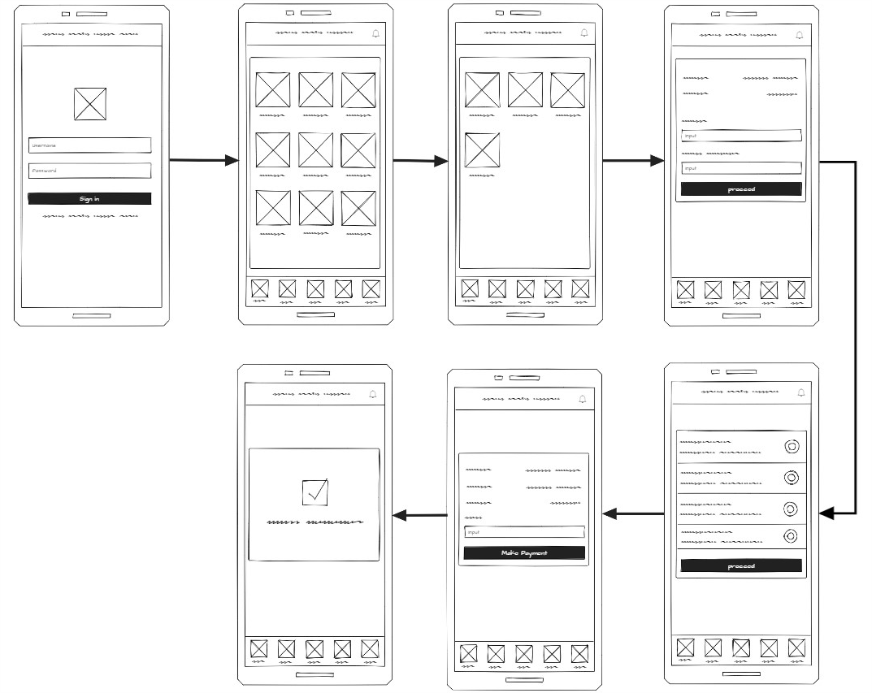

Notifications

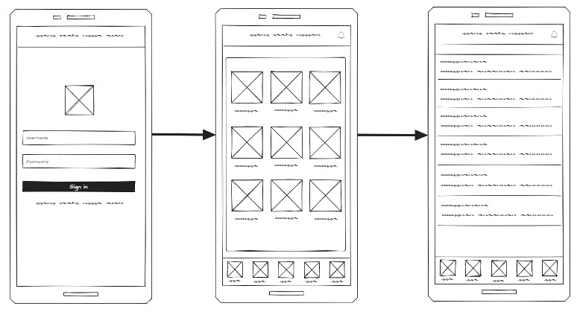

**Wireframes**

Bill Payment

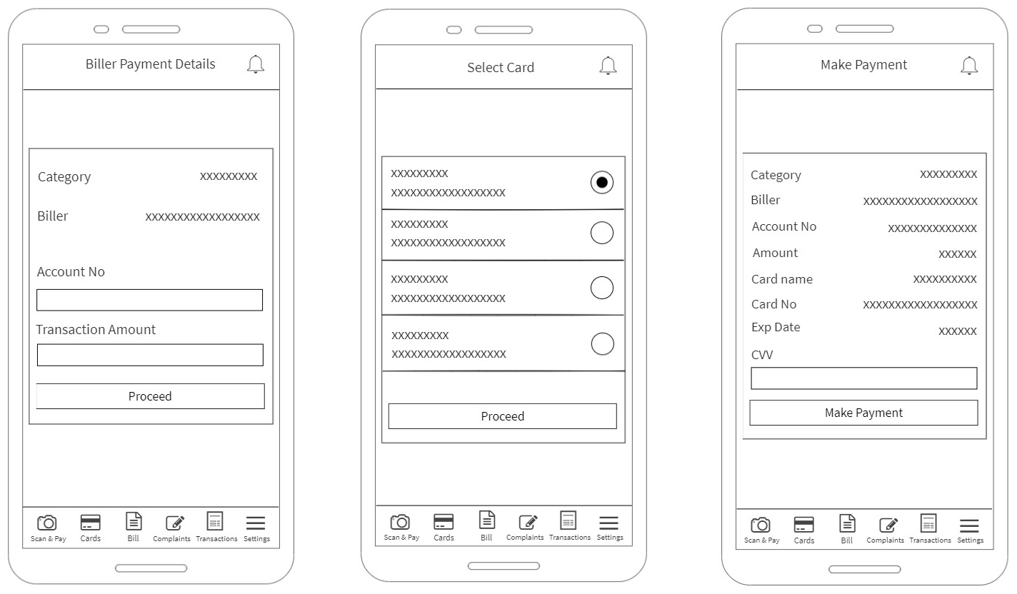

Notifications

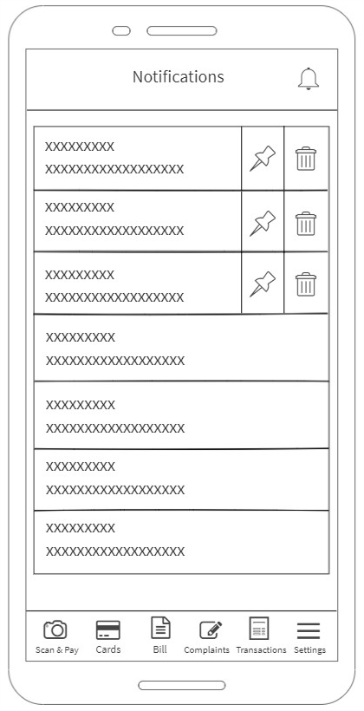

**Prototype**

Version 01

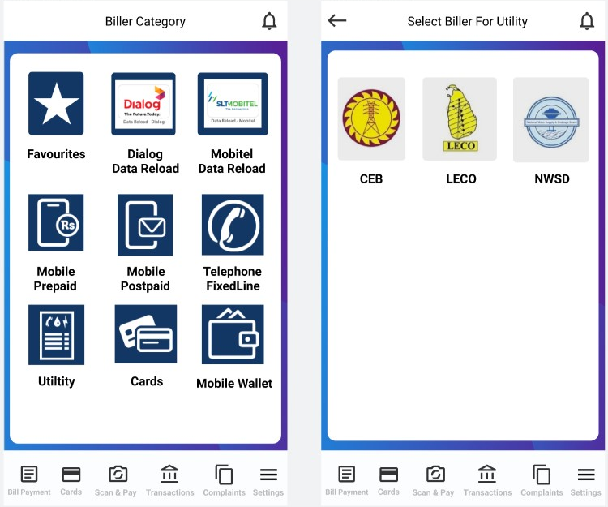

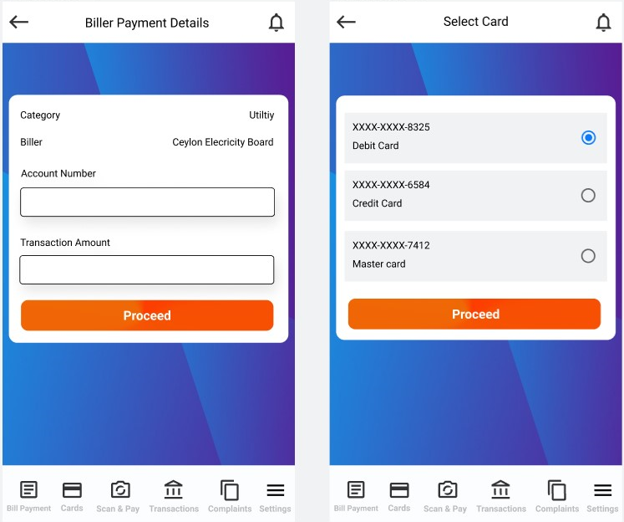

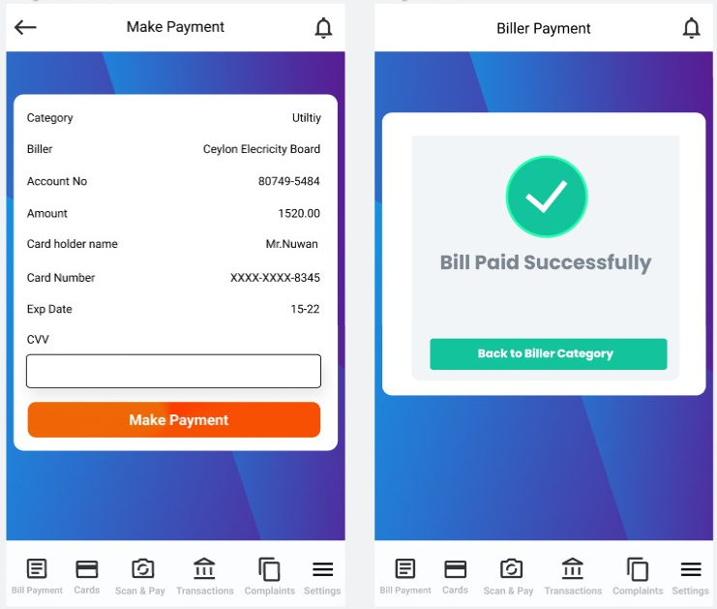

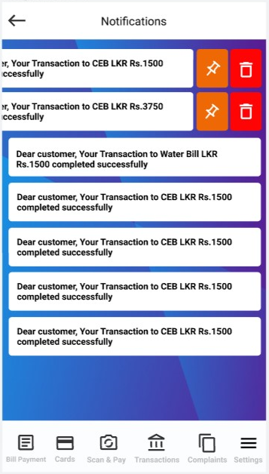

Version 02



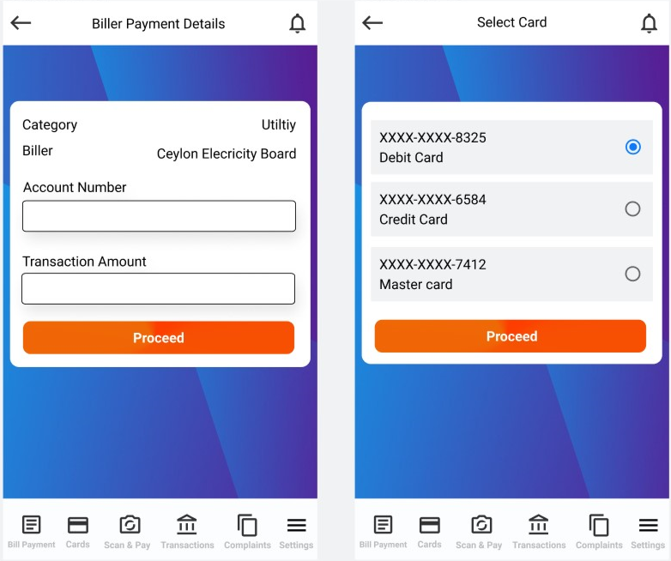

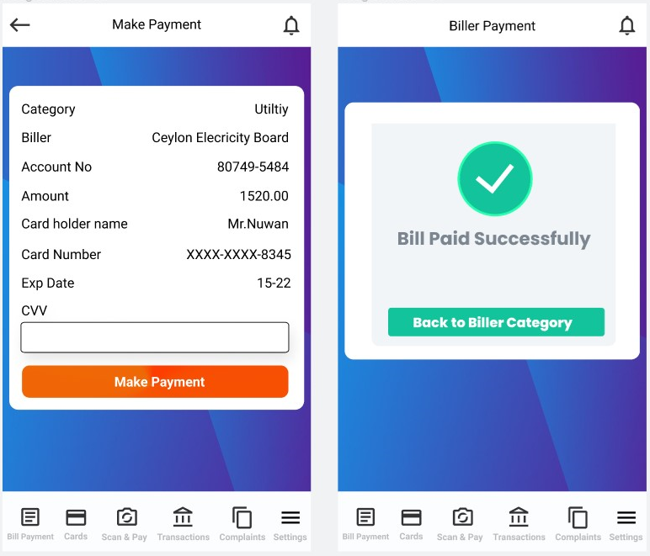



Member 01 – IT19153414 Akeel M.N.M Contribution

Drew Sketch for Bill Payment feature and Notification feature

Drew Wireframe for Bill Payment feature and Notification feature

Designed Prototype Version 01 and Version 02 for Bill Payment feature and Notification feature

**Member 02 – IT19175126 Zumry A.M**

**Sketches**

Add Card

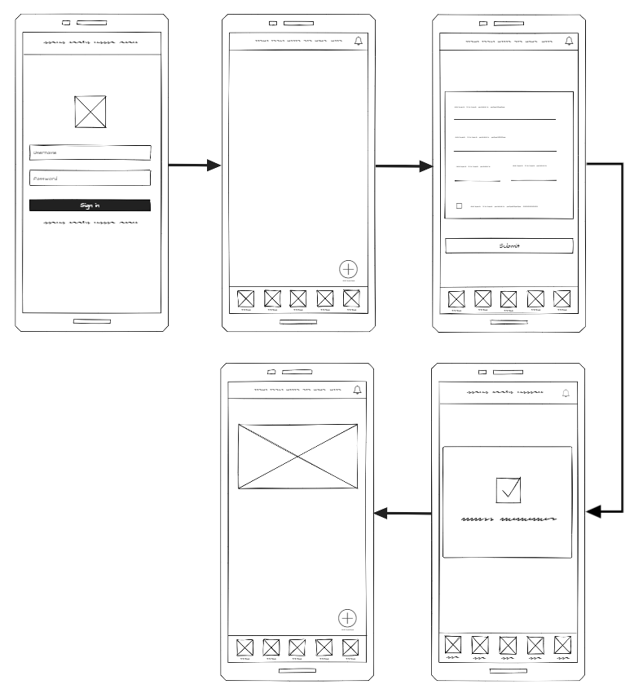

Make Transaction

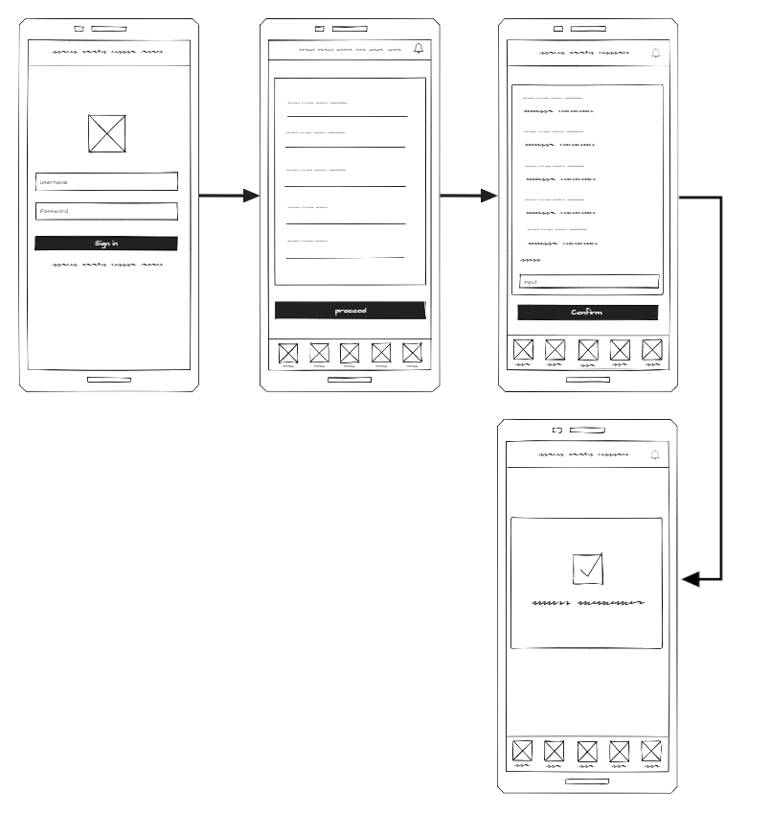

Remove Card

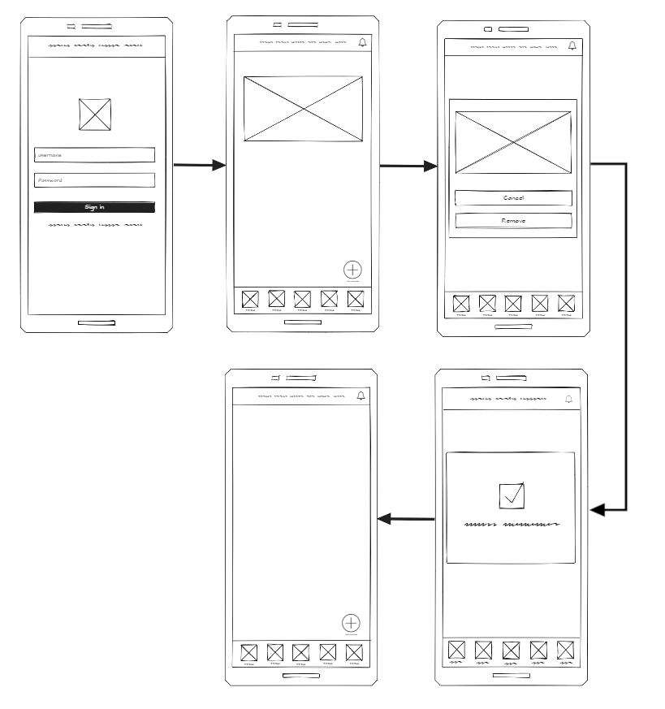

**Wireframes**

Transaction

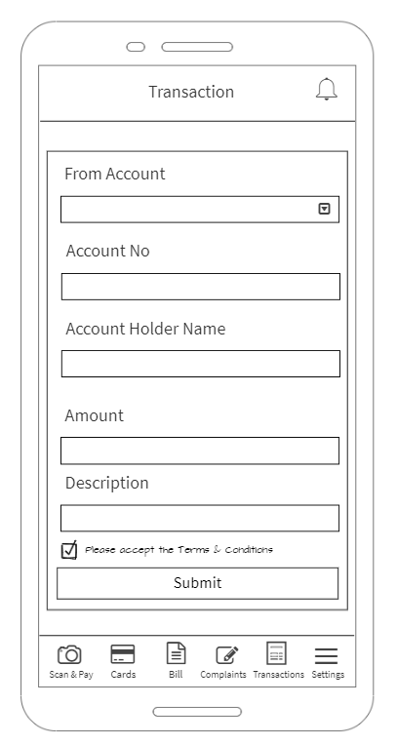

Card Management

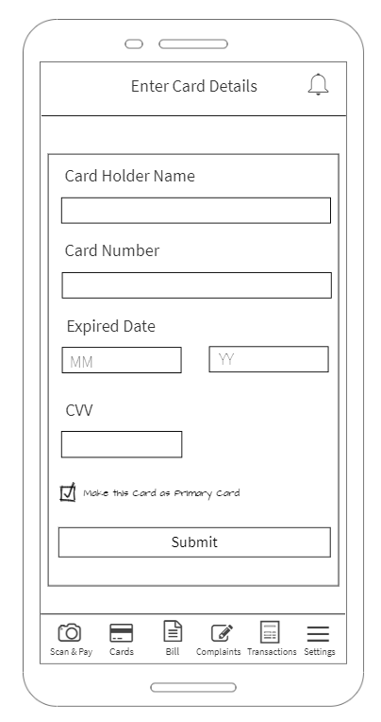

**Prototype**

Version 01

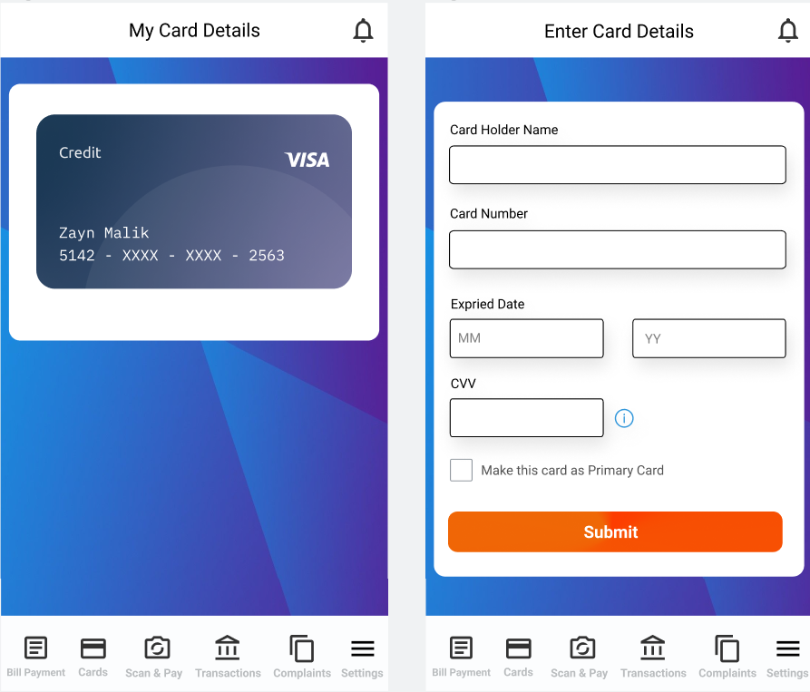

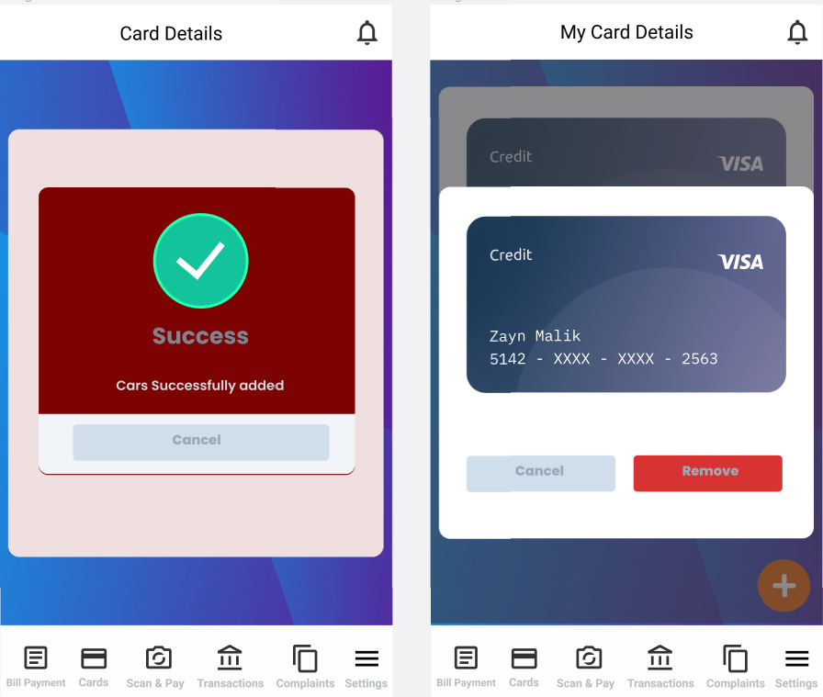

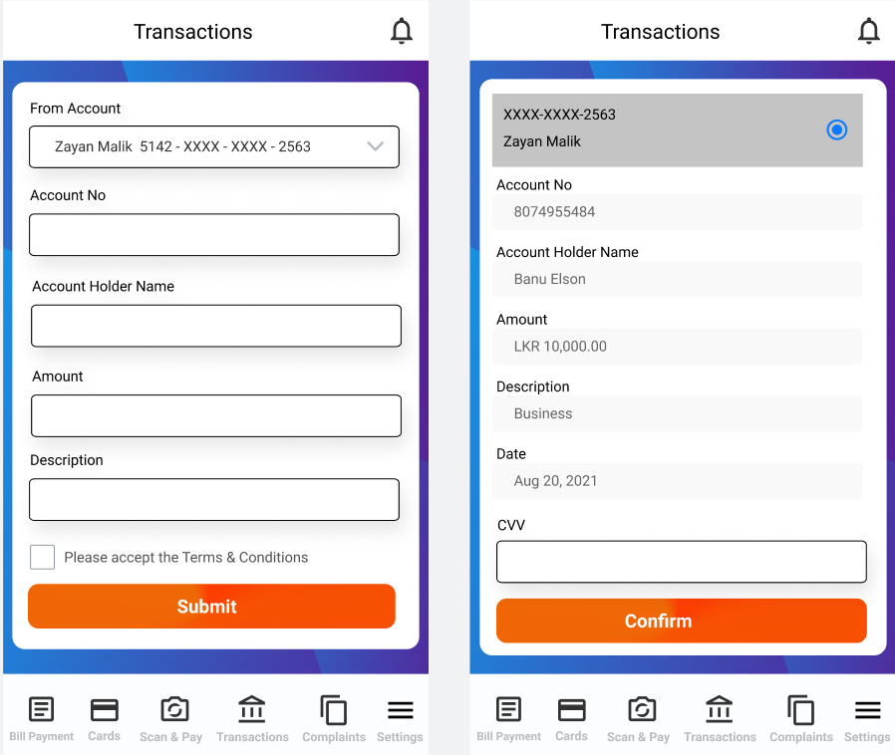

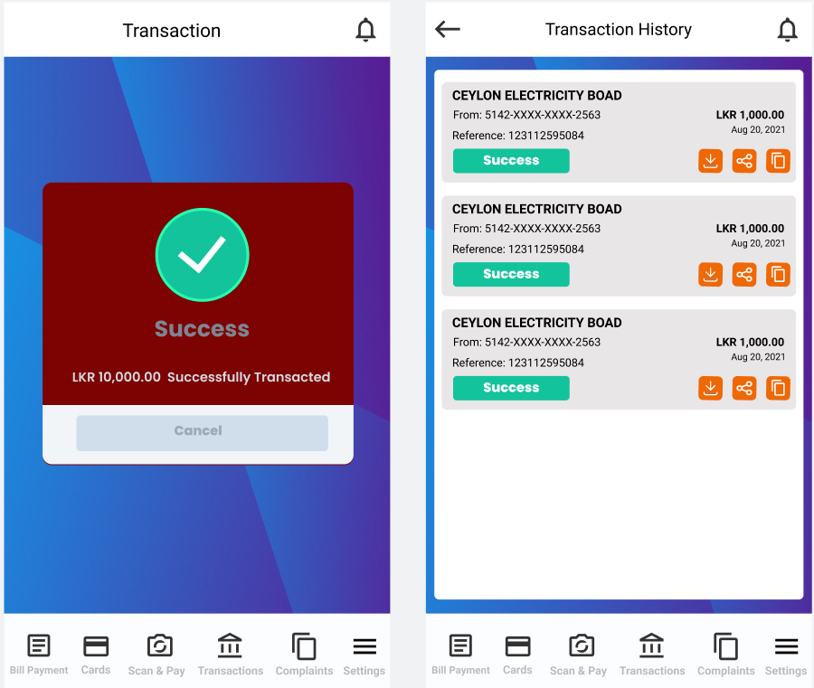

Version 02

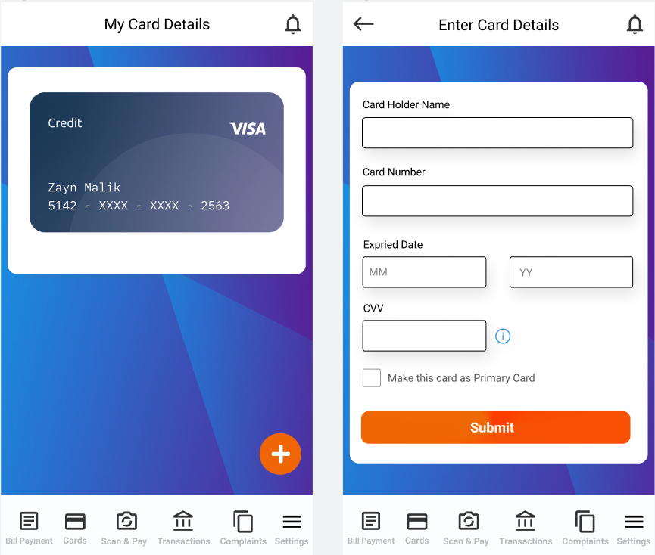

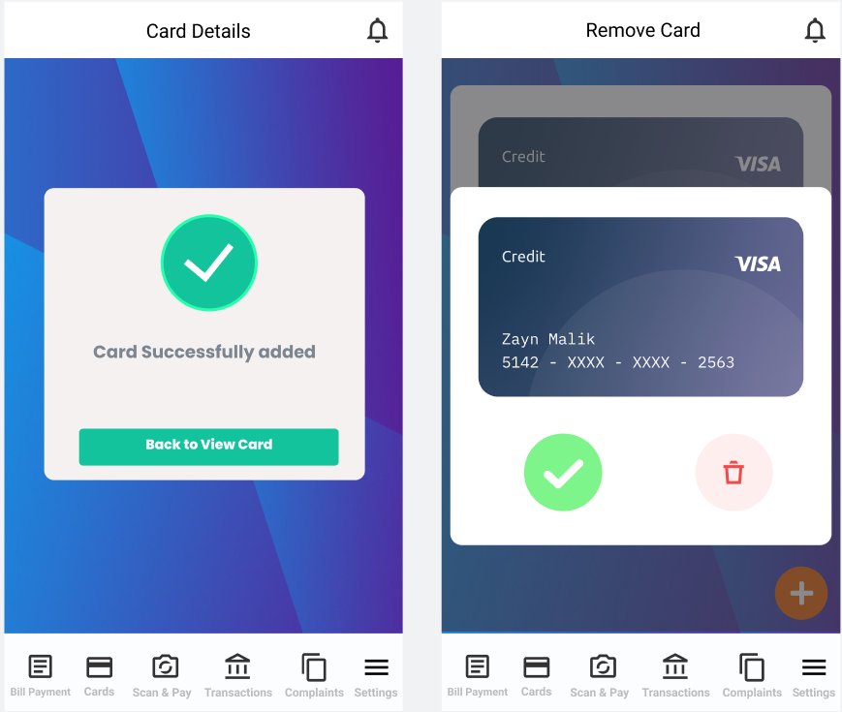

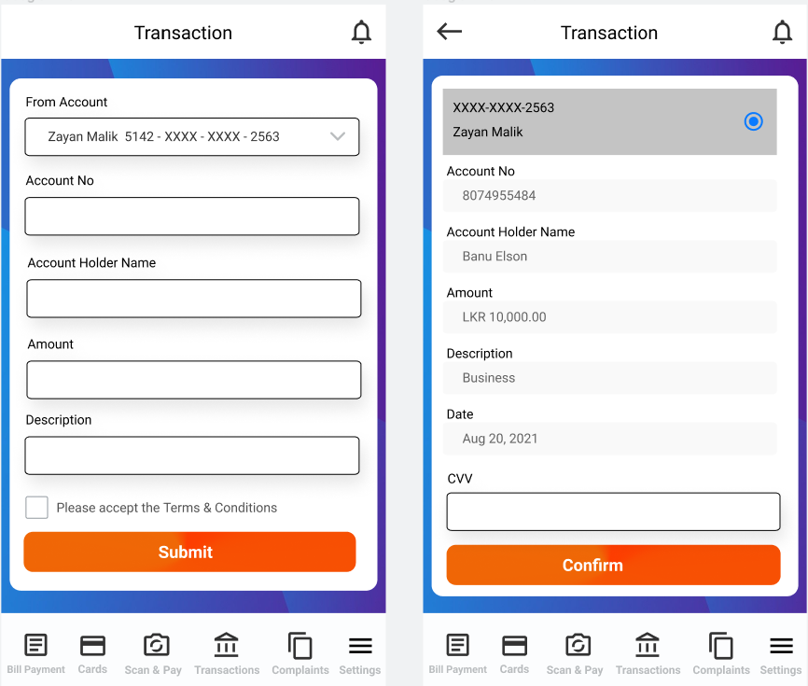

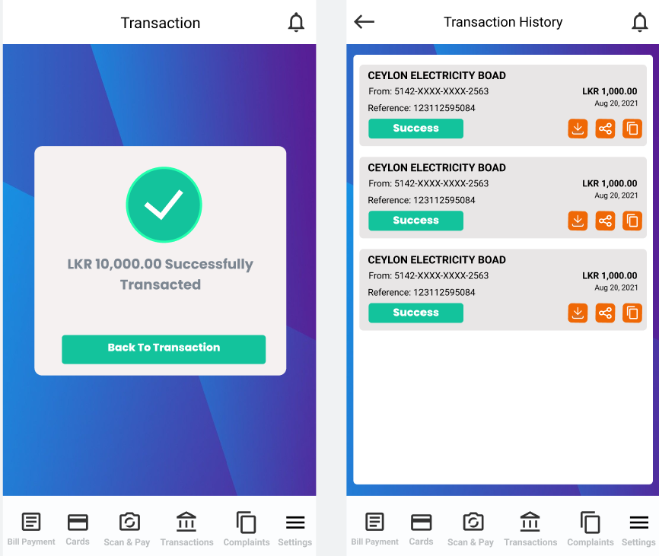

Member 02 – IT19175126 Zumry A.M Contribution

Drew Sketch and wireframe for Add Card feature, Transaction feature and Remove Card feature.

Designed Prototype Version 01 and Version 02 for Card Management feature, Transaction feature and Transaction History page.

**Member 03 – IT19167442** **Nusky M.A.M**

**Sketches**

Login, Register and Forgot PIN

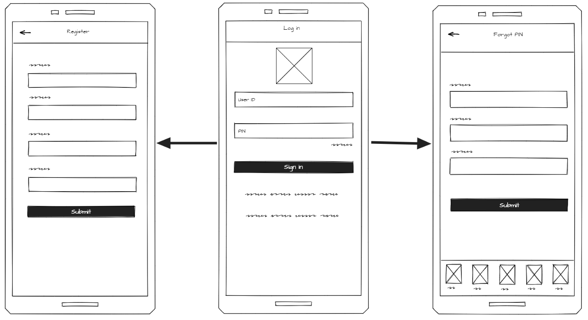

Add Complaint and view Complaints

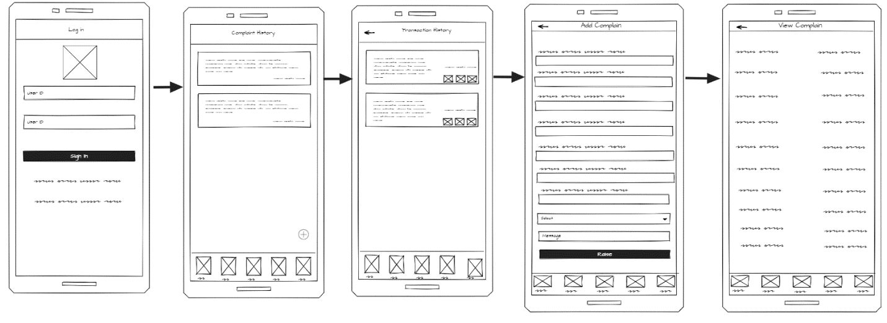

Customer Profile and Change PIN

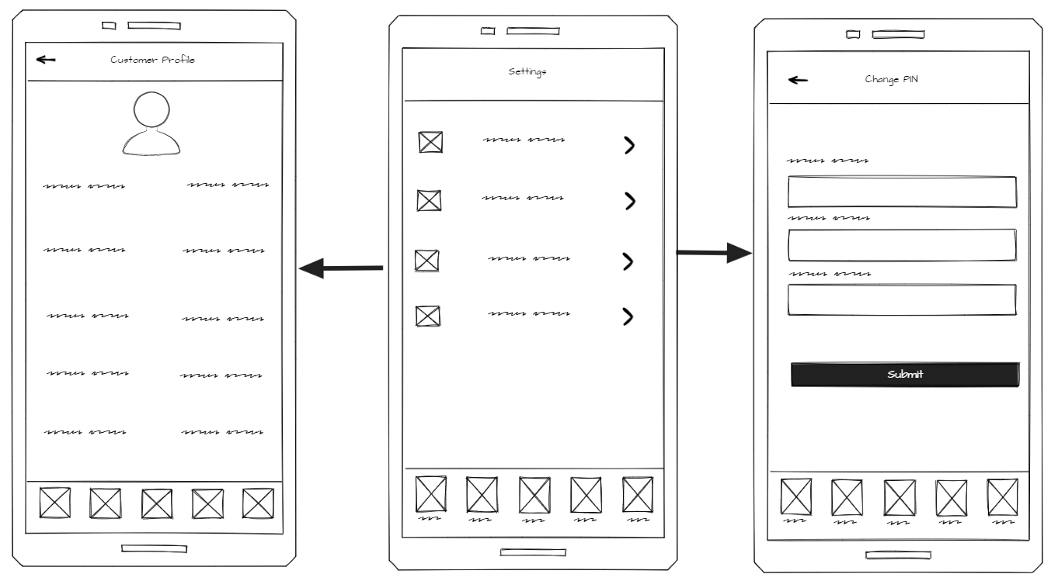

**Wireframes**

Login, Register

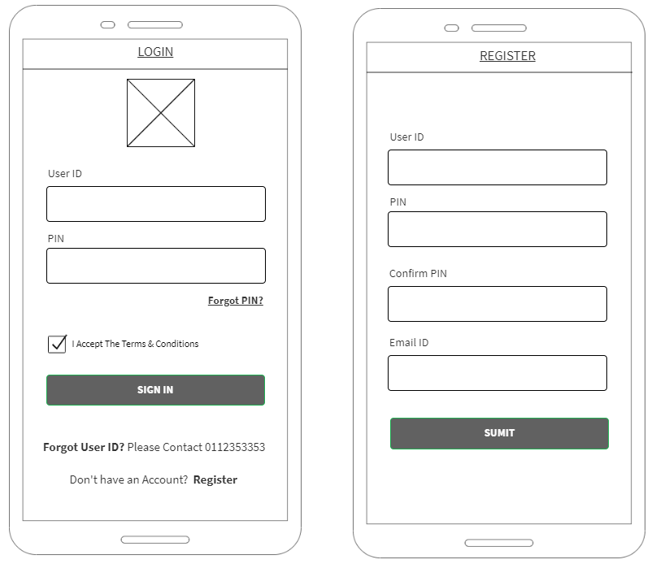

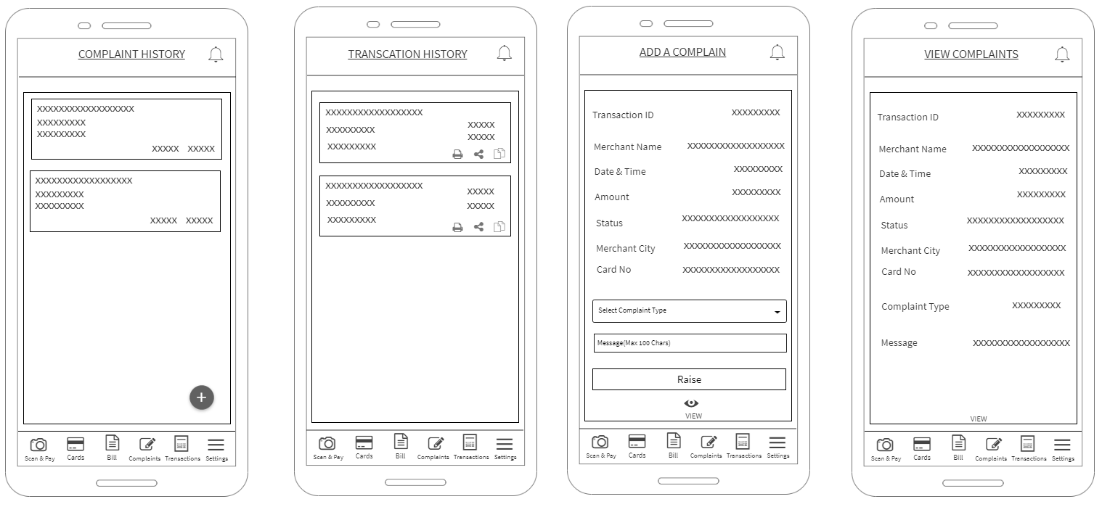Add Complaint and view Complaints

**Prototype**

Version 01

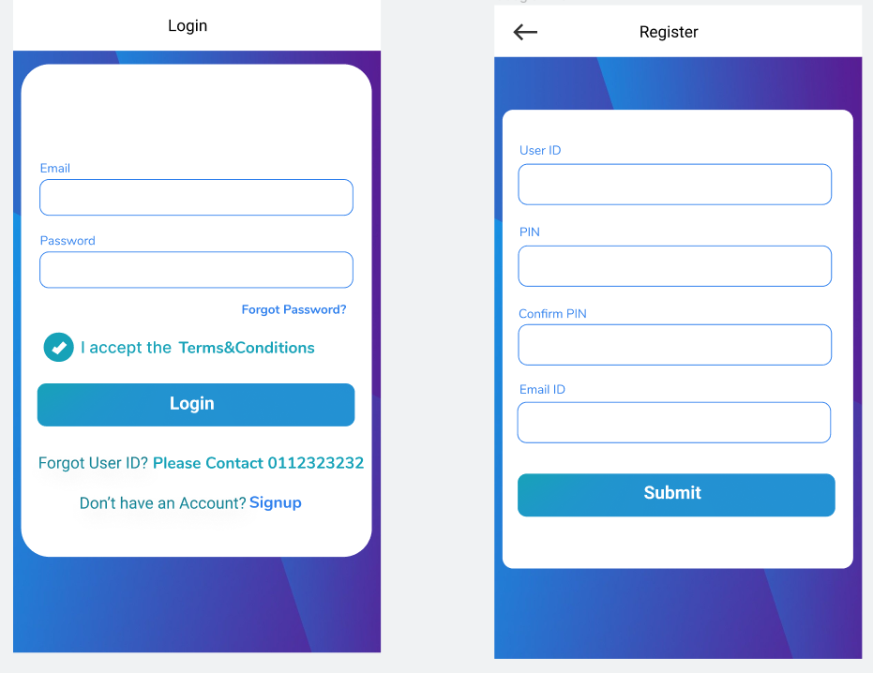

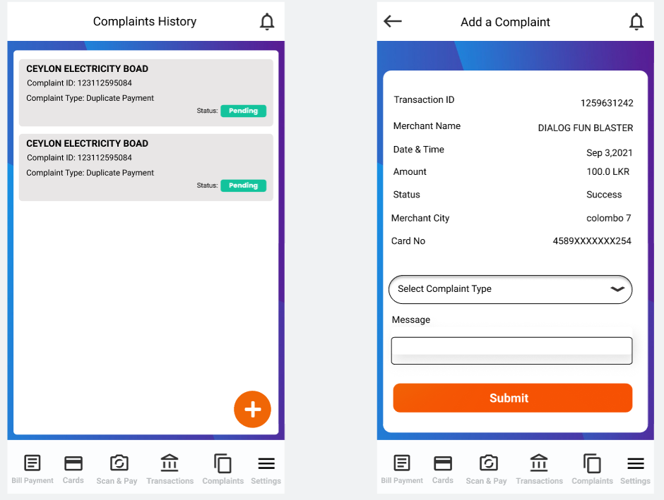

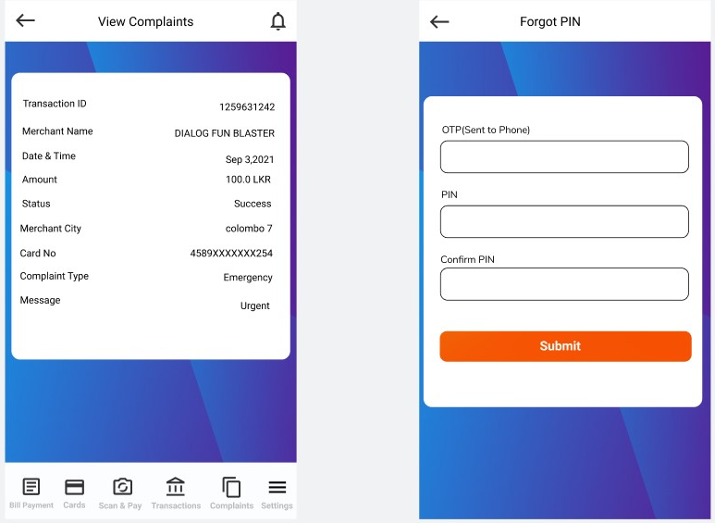

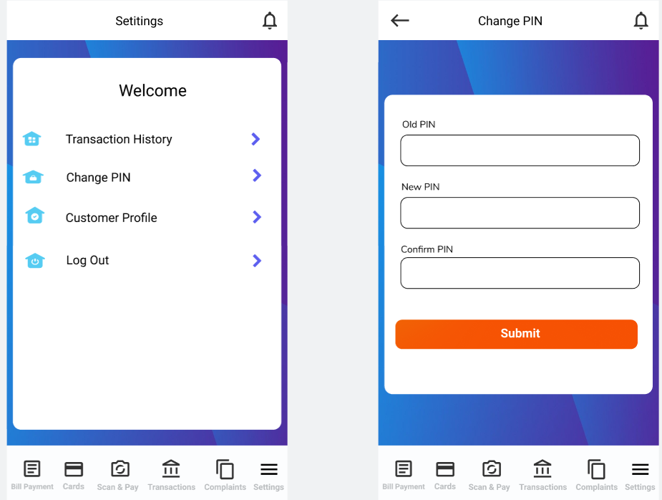

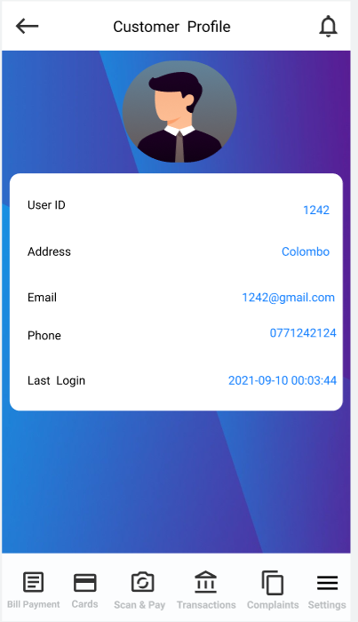

Version 02

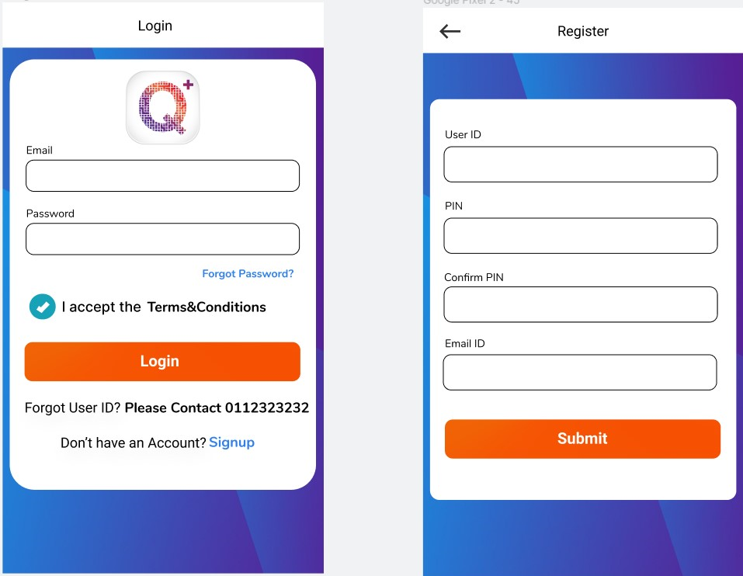

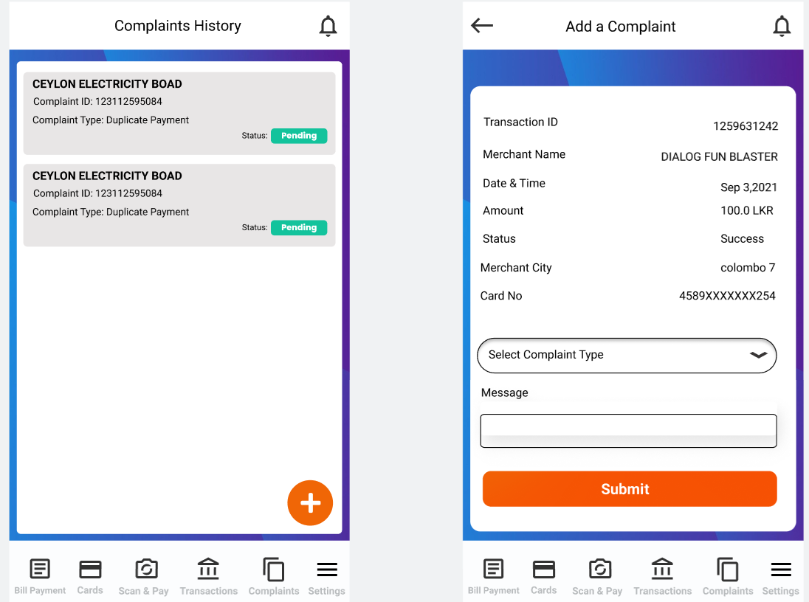

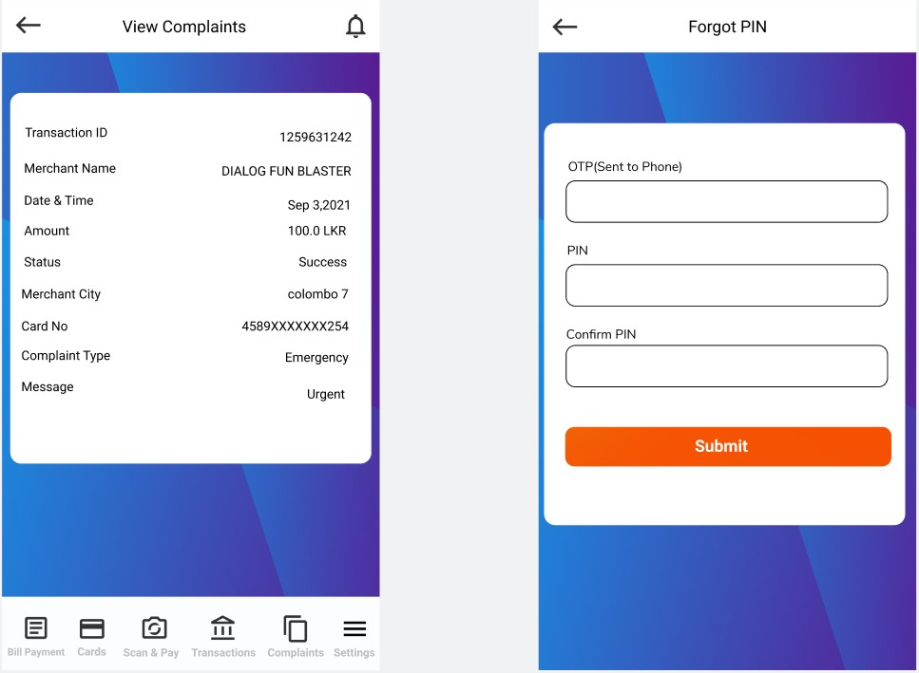

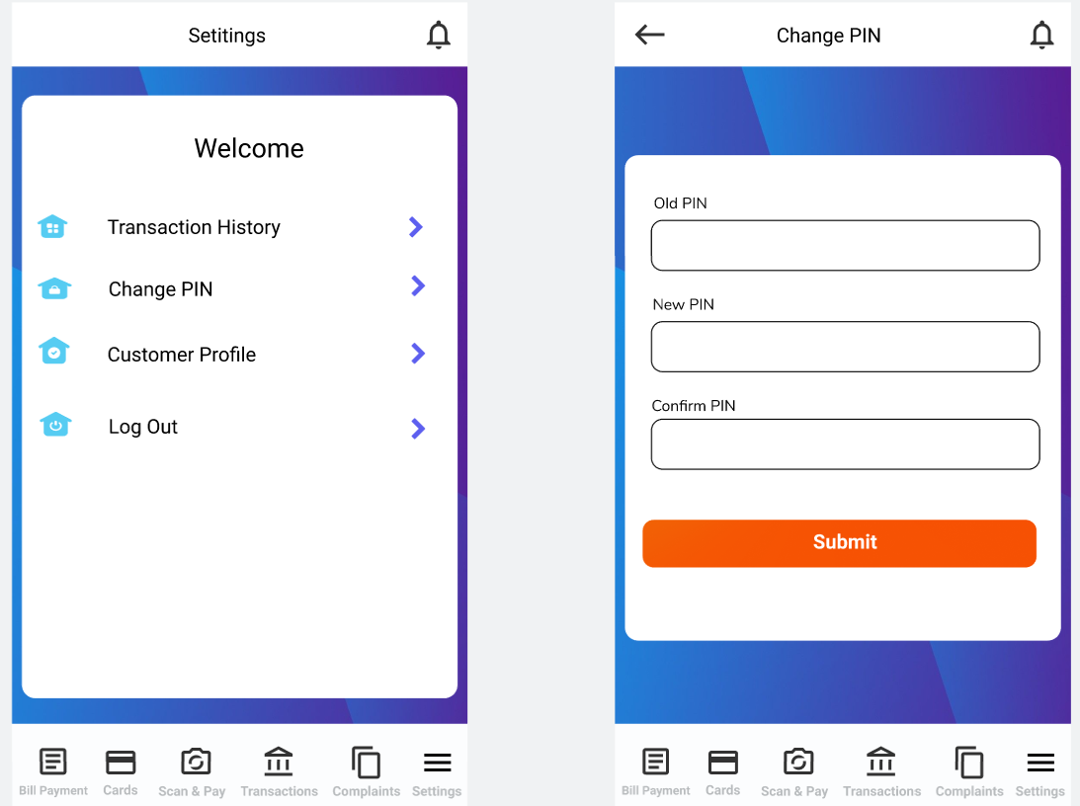

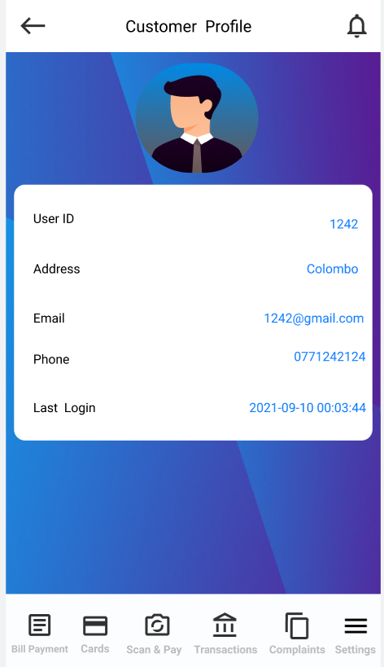

Member 03 – IT19167442 Nusky M.A.M Contribution

Drew Sketch for Login, Signup, Forgot PIN, Change PIN, Customer Profile features and Add Complaint, Complaint history and View Complaint features

Drew Wireframe for Login, Signup Feature and complaint Feature.

Designed Prototype Version 01 and Version 02 for Login, Signup, Forgot PIN, Change PIN, Customer Profile features and Add Complaint, Complaint history and View Complaint features

**Prototype Links**

Prototype Version 01 Link: <https://www.figma.com/proto/q0PPMbbAa7ntZcqxl6fsFh/Nusky-s-team-library?page-id=312%3A2&node-id=372%3A585&viewport=241%2C48%2C0.33&scaling=scale-down&starting-point-node-id=372%3A585>

Prototype Version 02 Link: <https://www.figma.com/proto/q0PPMbbAa7ntZcqxl6fsFh/Nusky-s-team-library?page-id=326%3A2&node-id=443%3A2146&viewport=241%2C48%2C0.09&scaling=scale-down&starting-point-node-id=443%3A2146>

**Interview Link**

Interview Video Link: <https://mysliit-my.sharepoint.com/:v:/g/personal/it19175126_my_sliit_lk/EX8MYIFHEUlAsOcc2xcqcKsB7PWgL6x3Q5vWareTcBoLQw?e=IAdEgk>

**Testing Script**

Hi, thank you again for taking the time to participate in this study. Before we begin, I’m going to give you a brief overview of the test and how it will work.  
This session is pretty straightforward — we will give our app prototype and then asking questions as we go along. Before we show you the prototype of the app, I’ll be giving you a little bit of context behind it, such as why you might be doing it and what you hope to achieve. We designed a prototype of the app we like to show it you and get your feedback to improve the prototype design and will ask some questions to make sure everything Is covered.  
If at any point you have questions, please don’t hesitate to ask. Do you have any questions so far?

So, let me start the testing I’ll share a link of the prototype you take a look at it and use it. After that I will ask some questions.

1. Do you have any questions so far?
2. So how is the iconography in this bill payment category screen?
3. How was the text hierarchy in the screens, I mean is the text are clear in the screen?
4. How were the text sizes in the screen is it readable?
5. how was the notification screen is it good or bad?
6. So, your mentioned there are no way to manage notification in our last interview so we added some functionality like delete and pin notification. so, it is good?
7. Okay last question. Is there are anything need to be improve in the porotypes of the both features?
8. So, do you have any questions so far?
9. Are the Manage Card interfaces easy to understand?
10. What was the one thing you dislike the most about the Manage Card UI Design?
11. What are you thinking as you look at Manage Card UI Designs?
12. If you could change one thing about the Manage Card interface design, what would it be?
13. Are the transaction interfaces easy to understand?
14. What was the one thing you dislike the most about the transaction UI Designs?
15. What are you thinking as you look at online transactions UI Designs?
16. What do you think about the login UI Now Is it Better or do I need to add anything?
17. What do you think about the responsiveness of buttons?
18. Are the icons used are looking good?
19. What do you think about the add complain interface?
20. Is the customer profile design looking good?
21. As you using it now after our first changes are the interfaces easy to understand?